OPTIMISE Management Committee Meeting – Minutes
Friday 24 February 2017
Meeting beginning 09:00am
Representatives for countries present: Antonis kavvadias, EL: Helge Aasen, Andreas Hueni, CH: Lars Eklundh, SE: Lea Hallik, EE: Radalsaw Juszczak, PL: Daniel Kovac, CZ: Hristo Nikolov, Rumiana Vatseva, BG: Javier Pacheco, ES: Krisztina Pinter, HU: Jean-Louis Roujean, FR: Joao Silva, PT: Dan Sporea, RO: Kyriacos Themistolceous, CY: Frank Veroustraete, BE: Loris Vescovo, IT: Martin Schlerf LU.
As 16 of the 29 countries which have signed the ES1309 “OPTIMISE” MoU were represented by MC members of MC substitutes there is a quorum therefore decision can be made
16 member country representatives were present for voting, and therefore decisions were able to be ratified at the meeting.

Introduction: – Alasdair Macarthur
The following core group structure was proposed for the final year of the project:
- Chair: Alasdair Macarthur
- Vice Chair: MaPi Cendrero
- Micol Rossini: Final Conference Leader
- WG1 Leader: Andreas Hueni; Coordinator, Shari van Wittenberghe
- WG2 Leader: Enrico Tomelleri; Coordinator, Helge Aasen
- WG3 Leader: Christiaan van der Tol; Coordinator, Javier Pacheco
- Training Leader: Radek Juszczak
- Dissemination Leader: Karolina Sakowska; coordinator Laura Mihai
- OPTIMISE BUS Lead, Helge Aasen
This was unanimously agreed by the MC

2. Grant Holder Report: - Action Manager and Chair
- The OPTIMISE budget for 2017 / 2018 will be 138,000 Euros. This will allow roughly 123,000 euros for Science Activities.
- The financial report for 2016/2017 showed a projected underspend of 14K. Contributory factors included having to cancel the training school planned for summer 2016 due to UAV flight restrictions imposed at the final stages of planning. More members registered for the Annual Workshop and MC meeting than have actually attended.
The Grant Holder Report was unanimously accepted by the MC

Report on Objectives still to be achieved by MEG Leader
The following objectives were noted as outstanding from the open floor discussion following Dirk Schuettemeyer’s presentation:
- Need to link our measurements to SI Units
- Need to consider fiducial reference measurements
- Better links with ICOS and COS
- FRM Handbook – ESA to publish
- Site Requirements – ESA to publish
- Collaboration with NASA – Petya Campbell
- Opportunity for ongoing living document – Sentinel 2,3 and FLEX
- H20/20 Sentinel 2 project proposal – Loris Vescovo
- Marco Dubbini – interest in thermal imager for UAVs based on MAIA platform
- Dan Sporea – proposal for cal lab for fluorescence measurement spectrometers and imagers
- Need to address issues of heterogeneity – Jon Atherton looking at a project
- Helge Aasen – develop protocols and procedures to address above OPTIMISE / BUS RADCAL network in place; to include vicarious calibration / homogenous targets Sentinel 1 & 3.
This was unanimously agreed by the MC as an accurate list of points raised in the discussion

WG Leaders’ proposals to achieve remaining objectives
Working Group 1
- Objective 1: EcoSYS and SPECNET collaborations ongoing / ecosystem specific metadata definitions need to be developed further (also input to ESA)
- Objective 2: majorly complete
- Objective 3: Nearing completion. The auto ingestion to SPECCHIO to be tested as proof of concept
- Objective 4: In progress but nearing completion
- Objective 5: Complete
Working group 2
- Objective 1:will be summarised in final OPTIMISE Report – this will be a review of OPTIMISE activities and outcomes
- Objective 2: An experts workshop was held for integrating the footprint tool by Prof. N.Kljun with Remote Sensing Data, February 2017
- Objective 3: industry has moved ahead of OPTIMISE but should invite industry to a workshop (invite to Belgium practical workshop)
- Objective 4: Work has begun (Bolzano workshop and AP/JA Hyytiala project but more effort required). Opportunity for workshop in Belgium ESA/VITO/Faculty of Science, Antwerp/OPTIMISE.
- It was proposed that Belgium to host an activity to address the last 2 objectives – no objections were raised from the members present.
Working Group 3
- Objective 1: OPTIMISE BUS and questionnaire ongoing
- Objective 2: Tartu think tank workshop & Romanian proposal Sporea / Macarthur. Practical spectrometer calibration workshop.
- Objective 3: SWAMP & ABEL to be available online database included, deliverable majorly complete but more data needed (Belgium workshop)
- Objective 4: more work needed to integrate UAV measurements - Belgium practical workshop to address including traceability and uncertainties.
- Wireless communication improvement – proof of concept to be completed.
- A means of addressing outstanding WG objectives included scope for 4 workshops and targeted STSMs.
The Progress Report and the status and proposed actions for the WGs were accepted and unanimously agreed by the MC

Training Leader and Dissemination Leader Proposals for final year
- Website had been updated to include information on STSM calls, Workshops, Training Schools, Progress Reports, Newsletters and Publications which are regularly updated. Further improvements would continue this year to include more publications, job opportunities and news items relating to OPTIMISE.
- The Chair requested members contribute to a list of publications relating to OTPIMISE for the website
- 3rd OPTIMISE Newsletter – Laura Mihai to join the dissemination group . Newsletter to include updates on recent workshops, WG meetings and activities.
- It was noted that OPTIMISE had made good progress towards inclusiveness of less research-intensive countries across Europe e.g. ESR workshop, Rumania; collaboration between Edinburgh University and Poznan and DLR to establish a Sentinel-2 mission cal/val field site in Romania; the Dubrovnik 2016 MC meeting and current meeting in Cypress.
- It was proposed that the Final Conference would be held in Sofia, Bulgaria (also an inclusiveness country). This would be February /March 2018. No objectives were raised to the proposal.
- Final Conference – sponsorship would be sought in addition to the amount allocated in the 17/18 budget plan.
- STSMs to be themed to address outstanding objectives during the final year.
The Training and Dissemination Reports and plans for the final year of OPTIMISE were accepted and unanimously agreed by the MC

6. Draft budget and work plan proposal for 2017/18 – Alasdair Macarthur
- The outline budget and work plan for 2017/18 below was presented and accepted by the Management Committee, to be ready by the end of March for approval prior to submission to COST.
The following countries offered or are available to host activities:
Final Conference: Sofia, Bulgaria;
MC meeting: Larissa, Greece or COST Office Brussels.
Science workshops: Luxemburg; Larissa, Greece; Samsun, Turkey;
Bucharest, Romania or COST Brussels.
The MC requested that capital cities with direct access be favoured for OPTIMISE activities
The following was proposed and accepted unanimously by the MC
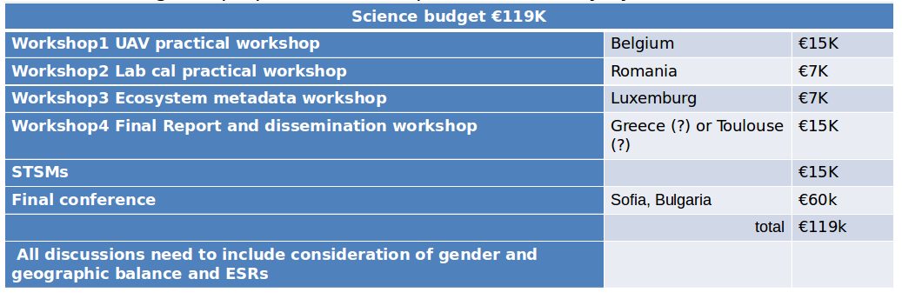

7. Any Other Business
- As there was no further business Dr Mac Arthur thanks everyone for attending and closed the meeting.

