Short Term Scientific Mission Report
COST Action OPTIMISE: ES1309

STSM Applicant: Bruna Oliveira
Bruna.Oliveira@ua.pt
Department of Environment and Planning
CESAM – Centre for Environmental and Marine Studies
University of Aveiro
Campus Universitário de Santiago
3810-193 Aveiro, Portugal

STSM topic: Modelling of ecosystem respiration with proximal sensing data and meteorological measurements

STSM reference number: COST-STSM-ES1309-34804
STSM type: Regular (from Portugal to Germany)

Period: from 2016-09-10 to 2016-09-24

Host: Mirco Migliavacca, Max Planck Institute for Biogeochemistry, Jena, Thuringia (DE), mmiglia@bgc-jena.mpg.de

Purpose of the STSM;
The main objective of the missions is to provide a training opportunity for the candidate: (i) to apply the different approaches that exist to combine proximal sensing data and meteorological measurements to model ecosystem respiration and to get insight into what the strengths and limitations of these approaches are; (ii) to explore the relationships of basal respiration with structural vegetation indices such as NDVI, MTCI, ND, EVI as well with vegetation indices related to physiological activity such as fluorescence and PRI.
The main motivation for the mission is that the candidate will be able to apply the acquired knowledge and understanding in the framework of the recent Portuguese project FIRE-C-BUDs (2016-2019), funded by the Portuguese Foundation for Science and Technology (FCT). FIRE-C-BUDs will study the indirect effects of wildfire occurrence and severity on carbon fluxes and budgets in maritime pine plantations by combining biometric measurements (changes in carbon pools) with point-scale measurements of instantaneous fluxes (soil efflux and photosynthesis) as well as stand scale measurements of continuous fluxes (eddy covariance). Most relevant in the present context, however, is that FIRE-C-BUDs foresees the use of UAV imagery for upscaling these point-scale measurements as well as for interpreting the temporal patterns in these stand-scale measurements in terms of ash mobilization as well as vegetation recovery.

Description of the work carried out during the STSM;
The main objective of the missions was: (i) to apply the different approaches that exist to combine proximal sensing data and meteorological measurements to model ecosystem respiration and to get insight into what the strengths and limitations of these approaches are; (ii) to explore the relationships of basal respiration with structural vegetation indices such as NDVI, MTCI, ND, EVI as well with vegetation indices related to physiological activity such as fluorescence and PRI.
First, a literature review was carried to get acquaint with the terminology, the ecosystem respiration models and the field campaign previously done by the host.
Second, a familiarization with the R program and previously developed scripts was done.
Third, the proximal sensing data and meteorological measurements were used as input to model ecosystem respiration. The relationships of basal respiration with structural vegetation indices such as NDVI, MTCI, ND, EVI as well with vegetation indices related to physiological activity such as fluorescence and PRI, were explored.

Description of the main results obtained;

- Experimental setup
The SMANIE – Small-scale Manipulation Experiment – project is running in a Mediterranean savannah in Majadas del Tietar, Spain. The focus of SMANIE is on the effects of N and P fertilization on ecosystem level C and water fluxes, plant traits, hyperspectral vegetation indices (VIs) and solar induced chlorophyll fluorescence (SIF) of the grassland layer.
Four blocks of 20 x 20 m were subdivided in four 9 x 9 m plots. In each bloc, 4 treatments were applied: control with no fertilization, nitrogen addition; phosphorous addition; nitrogen and phosphorous addition. Within each plot there were 2 permanent manual static chambers built in-house (Perez-Priego et al., 2015) to monitor CO₂ fluxes (net ecosystem CO₂ exchange NEE and daytime ecosystem respiration) that allowed computing the GPP. Hyperspectral data were measured with a built-in-house manual high resolution spectrometric system, based on (Rossini et al., 2015), and capable to collect canopy spectral reflectances with the spectral resolution adequate to compute the majority of VIs foreseen in the novel satellite missions, as well as SIF.
The available data was:
- Diurnal ecosystem respiration measurements;
- Land Surface Temperature (LST);
- Soil and air temperature;
- Soil water content;
- Midday observations of canopy reflectance and SIF at 760 nm.

More details about the experimental design can be found in (Perez-Priego et al., 2015).

- Method
The ecosystem respiration, R_{eco}, can be determined from the basal respiration, R_{b}, a function of temperature and a function of precipitation, following the Lloyd and Taylor model:
$$R_{eco}=R_{b}×f(T)×f(P)$$

The temporal and spatial variability of R_{b} is related to productivity and photosynthesis as observed by several authors (Migliavacca et al., 2011)
This opens perspective to use remote sensing information to determine R_{b} and therefor to develop diagnostic empirical models of R_{eco} driven by remote sensing information.
However, it is not clear whether R_{b} is more related with:
- structural indices, such as:
  - NDVI – normalized difference vegetation index;
  - MTCI – MERIS terrestrial-chlorophyll index;
  - EVI – enhanced vegetation index;
or with
- physiological activity indices, such as:
  - Fy760 – sun-induced chlorophyll fluorescence yield computed at 760 nm;
  - PRI – photochemical reflectance index.
and which is the best model structure to predict the R_{eco} from remote sensing data and meteorological data.
To answer these questions we applied 2 different analysis:
- we estimated R_{b} using a variety of R_{eco} empirical models and we evaluate how we can better predict R_{b} using directly remote sensing data.

- the different vegetation indices obtained from proximal sensing measurements were used as input for the R_{eco} model (Migliavacca et al., 2011)
$$R_{eco}=R_{b}×e^{\left(Eo×\left[\frac{1}{T_{ref}-T_{0}}-\frac{1}{T-T_{0}}\right]\right)}$$
where
$$LinGPP: R_{b}=p1+p2×GPP$$

$$RecoVIs: R_{b}=p1+p2×VIs×PAR$$

The GPP is a driver of R_{eco}, and was forced in the models after being measured (LinGPP) or model (RecoVIs) using only 1 or 2 VIs as drivers in a multiple linear regression model. Model parameters (p1, p2) were optimized against R_{eco} observations.
The diurnal cycle of Reco was simulated using midday Vis and meterological data. The results were evaluated against observations computing R2, modelling efficiency (EF), root mean squared error (RMSE), and mean absolute error (MAE).

- Results
The results for the GPP modelled with VIs in relation with the GPP calculated from the measured CO₂ fluxes is summarized in Table 2. In general, the results for the models with 2 VIs as input are better than with 1 VIs.
Table 1: Summary of correlation coefficients for GPP modeling
Drivers | Model | RMSE | EF | R2 | RRMSE | MAE | N
sPRI | Linear 1 VIs | 3.906982 | 0.641128 | 0.673615 | 33.91749 | 3.101389 | 552
F760 | Linear 1 VIs | 4.457551 | 0.532857 | 0.563488 | 38.69711 | 3.494642 | 552
sPRI, NDVI | Linear 2 VIs | 3.549348 | 0.703821 | 0.733369 | 30.81278 | 2.785151 | 552
NFSFM, NDVI | Linear 2 VIs | 3.604361 | 0.694569 | 0.722718 | 31.29036 | 2.83936 | 552
sPRI, ND | Linear 2 VIs | 3.716955 | 0.675188 | 0.703536 | 32.26782 | 2.877639 | 552
NFSFM, ND | Linear 2 VIs | 3.731202 | 0.672693 | 0.700327 | 32.3915 | 2.894161 | 552
sPRI, MTCI | Linear 2 VIs | 3.871707 | 0.647579 | 0.680294 | 33.61126 | 3.072197 | 552

The correlation between R_{b} modelled and the R_{b} observed seems to be good for the tested drivers (Figure 1).
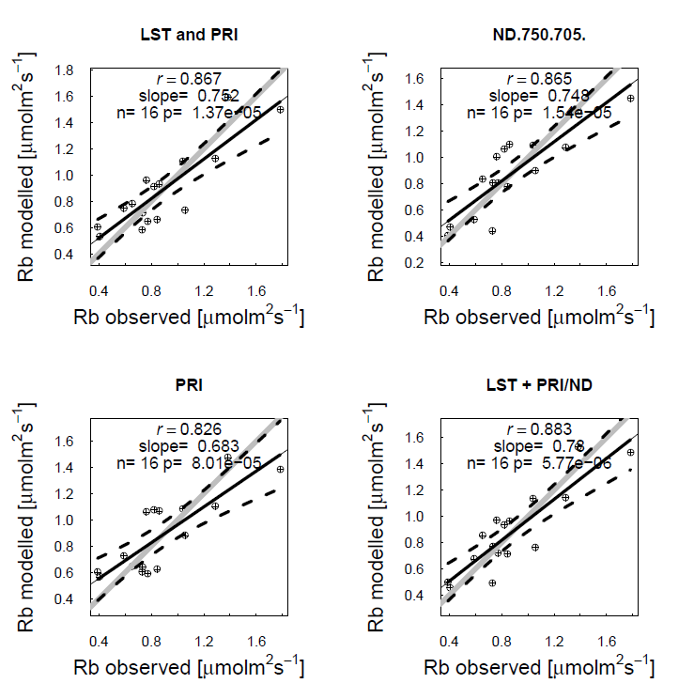
Figure 1: Correlation between Rb modelled and Rb observed

The correlation between the modelled R_{eco} and the measured R_{eco} are summarized in Table 3. In general, the LinGPP model gives better results than the RecoVIs model.
Table 2: Summary of correlation coefficients
Drivers | Model | RMSE | R2 | RRMSE | MAE | N
GPP | LinGPP | 1.509945 | 0.763396 | 26.02101 | 1.138497 | 552
GPP, Fy760 | LinGPP | 2.318917 | 0.441882 | 39.96209 | 1.863948 | 552
GPP, sPRI, NDVI | LinGPP | 1.929837 | 0.613496 | 33.25704 | 1.52736 | 552
GPP, NFSFM, NDV | LinGPP | 1.954743 | 0.603456 | 33.68625 | 1.546765 | 552
GPP, sPRI, ND | LinGPP | 2.005056 | 0.582794 | 34.55329 | 1.599879 | 552
GPP, NFSFM, ND | LinGPP | 2.00996 | 0.580749 | 34.63781 | 1.600639 | 552
GPP, sPRI, MTCI | LinGPP | 2.079742 | 0.551106 | 35.84037 | 1.66468 | 552
sPRI | RecoVIS | 2.815118 | 0.177475 | 48.51317 | 2.40525 | 552
MTCI | RecoVIS | 2.614509 | 0.290526 | 45.05605 | 2.18206 | 552
NDVI | RecoVIS | 2.216308 | 0.490181 | 38.19381 | 1.822632 | 552
NFSFM | RecoVIS | 2.139308 | 0.52499 | 36.86688 | 1.711217 | 552
F760 | RecoVIS | 2.192998 | 0.500849 | 37.79211 | 1.734163 | 552
ND | RecoVIS | 2.035152 | 0.570118 | 35.07194 | 1.631183 | 552

- Conclusion
The preliminary conclusions of the STSM show that basal respiration R_{b} can be successfully predicted using vegetation indices related to canopy structure, but also with a combination of LST and VIs related to physiology (e.g. PRI). Regarding the opportunity to model R_{eco} using remote sensing data, it can be seen that some results are promising with very good performance of some model structures. The model including NDVI and PRI in the R_{b} term is the one that better reproduced the diurnal cycle of R_{eco} (EF=0.62). Further tests on parameters and models have to be performed before consolidating the conclusions.

References

Migliavacca, M., Reichstein, M., Richardson, A. D., Colombo, R., Sutton, M. A., Lasslop, G., … Van Der Molen, M. K. (2011). Semiempirical modeling of abiotic and biotic factors controlling ecosystem respiration across eddy covariance sites. Global Change Biology, 17(1), 390–409. https://doi.org/10.1111/j.1365-2486.2010.02243.x
Perez-Priego, O., Guan, J., Rossini, M., Fava, F., Wutzler, T., Moreno, G., … Migliavacca, M. (2015). Sun-induced chlorophyll fluorescence and photochemical reflectance index improve remote-sensing gross primary production estimates under varying nutrient availability in a typical Mediterranean savanna ecosystem. Biogeosciences, 12(21), 6351–6367. https://doi.org/10.5194/bg-12-6351-2015
Rossini, M., Nedbal, L., Guanter, L., A??, A., Alonso, L., Burkart, A., … Rascher, U. (2015). Red and far red Sun-induced chlorophyll fluorescence as a measure of plant photosynthesis. Geophysical Research Letters, 42(6), 1632–1639. https://doi.org/10.1002/2014GL062943

Future collaboration with the host institution (if applicable);
On short term it is planned to continue with the analysis of the data and to write a manuscript to submit to an international peer-reviewed journal. On a long term the possibility of joint research and future collaboration is being explored.

Foreseen publications/articles resulting from the STSM (if applicable);
An article expected to be finished by the end of 2016.

Confirmation by the host institution of the successful execution of the STSM;
(it might be separate document written and signed by the Host - confirmation of acceptance from a senior Researcher affiliated to the Host institution formally accepting the scientific report.)

URGENT:
- The grantee is required to submit a short scientific report to the host institution (for information) and OPTIMISE Secretariat (optimise@aber.ac.uk) and STSM coordinator: radoslaw.juszczak@up.poznan.pl for approval within 30 days after the end date of the STSM.
- The failure to submit the scientific report within 30 days will effectively cancel the grant;
- The MC Chair (or the STSM coordinator) is responsible for approving the scientific report and informing the Grant Holder that the STSM has been successfully accomplished;
- After receipt of the approval by email, the Grant Holder will execute the payment of the grant.

