Short Term Scientific Mission Report
COST Action OPTIMISE: ES1309

STSM Applicant: Mr. Dimitri Dauwe, dimitri.dauwe@uhasselt.be
Agoralaan Gebouw D, 3590 Diepenbeek, Belgium

STSM topic: List and quantify some limitations of the FluSpect model

STSM reference number: COST-STSM-ES1309-XXXXXXXXXXXXX
STSM type: Regular (from X country to Y country)

Period: from 2016-11-14 to 2016-12-16

Host: Prof. Christiaan van der Tol, c.vandertol@utwente.nl, ITC (University of Twente), Hengelosestraat 99 7514 AE Enschede, The Netherlands

Purpose of the STSM;

For many years already, spectroradiometres are used to study structural and physiological features of vegetation. The non-destructive approach of these spectroradiometres is one of the main advantages. No contact with the target is needed which makes it suitable for remote sensing. This way vast areas could be monitored in a very cost and labour efficient way (Julitta et al. 2016). The analysis of the reflectance spectra becomes more and more automated thanks to the development of models. Models allow to retrieve biophysical features from the measured spectra and also enable to predict spectral curves from biophysical parameters (forward simulations) (Pablo et al. 2015).

Besides reflectance and transmittance, researches focus on chlorophyll fluorescence as well nowadays. Chlorophyll fluorescence is basically light, absorbed by plants, re-emitted back into the atmosphere. The level of fluorescence depends on the photosynthetic efficiency which in turn is correlated to environmental conditions. Exposure to excessive light, heat, soil/water/air pollution, nutrient deficiency, and other stresses all adversely affect the photosynthetic efficiency inducing an elevated chlorophyll fluorescence signal. Although this signal is very tiny to detect and sensitive to environmental conditions, it appears to be a good indicator for stress (Van Wittenberghe et al. 2013).

To interpret the signal correctly, it is important to measure biophysical and physiological parameters simultaneously with spectroradiometres. Chlorophyll fluorescence is indeed not the only pathway for plants to dispose excessive light energy. It is in constant competition with heat dissipation and non-photochemical quenching (regulated by xanthophyll cycle). Measurements with the pulse-amplitude modulation (PAM) and to a lesser extent the plant efficiency analyzer (PEA) are perfect additions in this perspective (Klughammer et al. 2008).

One of the main challenges remains to link both active and passive measurements. Active measurements, like the PEA and PAM, have the advantage to study the kinetics of the photosynthetic mechanism, whilst passive measurements, like spectroradiometres, can only study the steady-state. The major difference between both approaches lies in the fact that the first technique uses blue or red light pulses compared to the sunlight used for the latter. Recently, many researchers focus on this issue (Porcar-castell et al. 2014).

Another issue is to optimize the fitting of simulated spectra to the actually measured spectra. This is not as straightforward as it seems because it dependent upon certain factors, some of them are discussed later on. This paper aims to validate the FluSpect model output of fluorescence. Fluorescence is retrieved at photosystem level, but there are limitations that need to be quantified.

Description of the work carried out during the STSM;

One of the reasons I applied for this STSM at Twente University is to get more familiar with the FluSpect model on the one hand, but also to get acquainted with the programming in MATLAB behind the model. Because I am a MATLAB-rookie it took me quite some time to adapt the scripts for our goal, which is testing how well the model performs for (i) different light sources and (ii) different chlorophyll content. To do this, I could rely on the expertise of Nastassia Vilfan, Peiqi Yang and Christiaan van der Tol (supervisor).
MinnGold mutants on the right
The International Institute for Geo-Information Science and Earth Observation (ITC, Twente University, The Netherlands) provided me with two datasets from previous SoyFLEX-campaigns conducted at Julich University (Germany) in 2015 to have a go. These datasets contained measurements with the FluoWat leaf clip (developed by Luis Alonso at Valencia University). The leaves were illuminated either with an artificial light source and sun-induced approach respectively, depending on their position in the canopy (top leaves were solar illuminated). Both campaigns measured Wild Type and MinnGold soybean plants with a high and low chlorophyll content respectively*. The measurements included reflectance, transmittance and chlorophyll fluorescence spectra with FluoWat leaf clip as well as miniPAM. I mentioned before that this combination of active and passive chlorophyll fluorescence measurements is particularly interesting to link one with the other with regard to interpret (remote sensing) spectral data correctly. From a biological perspective, I want to emphasize the importance of investigating the different aspects in the plants physiology (certainly non-photochemical quenching and heat dissipation) contributing to the chlorophyll fluorescence signal before being able to draw reliable conclusions.

Anyhow, after a lot of effort to get the scripts right I could finally play around with the model. The first thing I checked was the specific absorption spectra and the specific fluorescence emission spectrum. These data were provided in a file consisting of wavelength and the corresponding absorption by pigments (chlorophyll, carotenoids) and the fluorescence emission spectrum of photosystems I and II. The Fluspect model uses these spectra to determine the absorption and emission in the leaf, which is then further used in a radiative transfer scheme for the leaf cros-section.

The model parameters can be retrieved by fitting the model to measurements by minimizing the quadrat of the difference between the measured and simulated spectra. This quadratic difference is the A cost function that is minimized to fit the simulation to the actually measured spectra. It seems to work quite well, though there are some limitations for the fluorescence emission efficiency parameter. This one appears to vary between certain conditions, to start with artificial or sun light and high or low chlorophyll content, as demonstrated in section ‘main results’. The parameters of the concentration of Zeaxanthin are only recently added by Nastassia Vilfan and is a first update in the FluSpect model to link active and passive measurements (Vilfan et al. 2016).
Prior to the calibration of the fluorescence emission spectrum, the input parameters including chlorophyll content, leaf water content, senescent material fraction, dry matter content, leaf thickness parameter, carotenoids and RMSE) are retrieved from a spectrum averaging 3 Wild Type and 3 MinnGold plants respectively. Ideally, the the fluorescence emission spectrum should not differ between the different situations.

*http://www.esa.int/Our_Activities/Observing_the_Earth/The_Living_Planet_Programme/Campaigns/FLEX_takes_on_mutants
Parameters included in ‘optipar’ file:
- nr = refractive index
- Kab = chlorophyll AB absorption spectrum
- Kcar = carotenoid absorption spectrum (um cm-2)
- Ks = senescent material fraction
- Kw = water absorption spectrum
- Kdm = absorption spectrum of dry matter
- flu = spectral shape of the fluorescence emission of photosystems I and II
- GSV1 = global soil vector 1 (for dry soil)
- GSV2 = global soil vector 2 (for dry soil)
- GSV3 = global soil vector 3 (for dry soil)
- KcaV = absorption spectrum of carotenoids in case no
- KcaZ = Zeaxanthin

Subsequently, I calibrated the spectral shape of the fluorescence emission (‘flu’) for Wild Type (WT) and MinnGold (MG) measured in sun light, and the performed forward simulations for different chlorophyll concentrations (5, 10, 15, 20, 30, 40, 50, 60) and study the differences between both for validation

For the time left at the ITC, I compared the outcome of the FluSpect model with the results presented in the paper “Leaf Chlorophyll Fluorescence Corrected for Re-absorption by Means of Absorption and Reflectance Measurements” by Prof. Anatoly Gitelson (1998) from the Remote Sensing Laboratory at the J. Blaustein Institute for Desert Research and Department of Geological and Environmental Sciences, Ben-Gurion University of the Negev (Israel).

Due to the simplicity of the equations in FluSpect-B a high computational speed is offered. With incident light provided as the main input parameter, Fluspect calculates the emission of ChlF on both the illuminated and shaded side of the leaf. Other input parameters are chlorophyll and carotenoid concentrations, leaf water, dry matter and senescent material (brown pigments) content, leaf mesophyll structure parameter and ChlF quantum efficiency for the two photosystems, PS-I and PS-II. The goal of this short scientific mission is to test the performance of the FluSpect model with SoyFlex data – as in comparison of the simulated data with measured data – and improve the fluorescence spectrum simulated by the model – as in fitting the simulated spectrum to the measured spectrum.

Description of the main results obtained;

Step 1: FluSpect Retrieval of input parameters from measurements

Table 1 shows a clear difference in chlorophyll pigment concentration between the two soybean species. The leaves of the MinnGold mutant are chlorophyll deficient and have thus a much less chlorophyll content compared to the Wild Type.

Table 1: FluSpect Retrieval of input parameters from measurements.

Species | Ca | Cw | Cdm | Cs | Cca | N | RMSE
MG | 18.00797 | 0.018875 | 2.06E-08 | 2.76E-14 | 5.674591 | 1.586714 | 1.749164
WT | 40.03291 | 0.025099 | 1.58E-09 | 0.389719 | 6.930747 | 1.692752 | 0.336781

Step 2: Calculation of optipars

Figure 1: Calculated fluorescence emission spectra from respectively transient data (artificial light source) and steady state data (sunlight). Transient data are measured on Wild Type only, whilst the steady state data are measured on both Wild Type and MinnGold soybean.
Firstly, figure 1 clearly shows the importance of characterizing the light source as the intensity per wavelength of an artificial light source deviates a lot from sunlight. Studies are ongoing to use a specialized combination of LEDs to imitate the sunlight as closely as possible.
Secondly, figure 1 also clearly shows a variation in optipars between the Wild Type and MinnGold soybean. This is a very interesting observation that needs to be further investigated as it impacts the modelling accuracy in many models applied nowadays, including FluSpect. Both soybean types differ significantly in chlorophyll content and is probably causing the change in the calculation of optipars. But why? Understanding the phenomenon is crucial in the development of an universal (dynamic) optipar.

Step 3: Retrieval of transmission and reflectance spectra for leaves with different chlorophyll contents ranging from 5 to 60

A standardized set of leaf parameters is used to retrieve a reflectance and transmittance spectrum. This processing is repeated while changing the chlorophyll content in the list of input parameters stepwise from 5 to 60 (figure 2). These spectra will then be used as input for fluorescence simulations in the next step.

Figure 2: Reflectance and transmittance for leaves with different levels of chlorophyll…

Step 4: Forward simulation of forward and backward fluorescence

Now, I have a fluorescence emission spectrum calculated for soybeans with respectively high and low chlorophyll levels and reflectance and transmittance spectra for a range of chlorophyll levels. This allows to visualize the forward and backward fluorescence gradually changing with chlorophyll content (figure 3), but also to calculate the differences between simulations performed with the alternative optipars (figure 4).
The largest differences are in the second fluorescence peak, especially in the case of backward fluorescence. The first peak is much less affected by the use of alternative optipars, although it is larger in case of forward fluorescence compared to backward fluorescence. The next question comes up: why are the difference largest in the second peak? The packaging effect (reabsorption effect) is suggested as a possible explanation. The FluSpect model is still limited to one spectrum for both photosystems, combining it with spectral PAM measurements (procedure developed by Waltz and Christian Frankenberg) could provide more information on this issue.

Figure 3: backward (Fb) and forward (Ff) chlorophyll fluorescence calculated with optipar calculated from Wild Type (WT) and MinnGold (MG) soybean respectively (see step 2).

Figure 4: Difference between simulations with alternatively the WT and MG optipar.
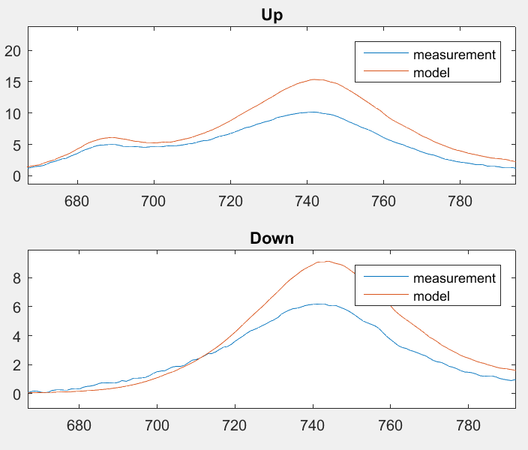 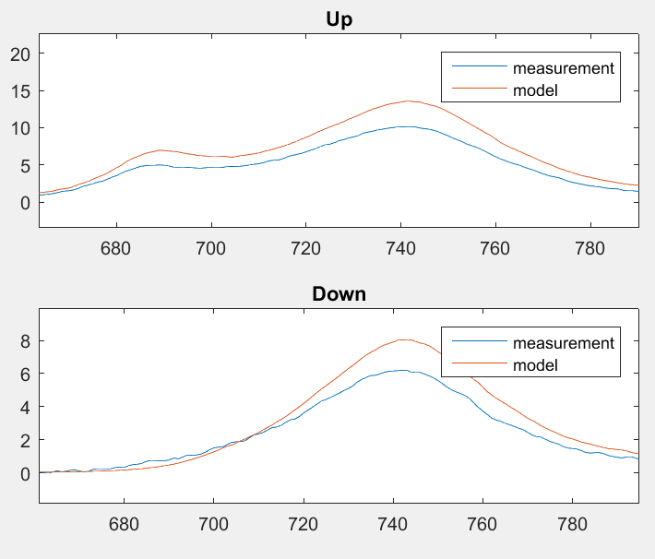Figure 5: left: measured spectrum compared to spectrum simulated with MG optipar, right: measured spectrum compared to spectrum simulated with WT optipar.

Step 5: Comparison with Anatoly Gitelson (1998)
B
A
E
F
D
C
Figure 6: From top leaf to bottom right: the ratio F685/F735 of the measured fluorescence emission at the wavelengths 685 nm and 735 nm plotted versus: A) ratio of sum of reflectance and transmittance at the same wavelengths, (R685 + T685)/(R735 + T735), B) ratio of reflectance at the same wavelengths, R685/R735, and C) reflectance at 685 nm, R685. The excitation wavelength was 430 nm. D) The measured chlorophyll fluorescence ratio F685/F735 versus the ratio of the non-absorbed radiation at 685 nm and 735 nm. i.e. the ratio of the sum of reflectance and transmittance at the same wavelengths (R685 + T685)/(R735 + T735) is plotted as well for different excitation wavelength namely 430, 550, 630 and solar spectrum.
Figure 6: Curvi-linear dependence of the measured chlorophyll fluorescence and reflectance (part A and B) on the chlorophyll content of differently pigmented leaves is studied. Against the chlorophyll content of the leaves are plotted E) the values of the measured chlorophyll fluorescence ratio F685/F735 and the ratio of non-absorbed radiation (R685 + T685)/(R735 + T735), F) the reflectance ratio R685/R735, and the reflectance at 685 nm.
The outcome from the simulations in FluSpect are similar to the ones in the paper of Anatoly Gitelson, which means the model is performing well. However, in Anatoly’s paper corrected for the re-absorption effect almost totally removing the dependence of the fluorescence ratio, here f685/f735, on chlorophyll content. This should still be implemented in the FluSpect model.

References
Spectroradiometers, F. (2016). Comparison of Sun-Induced Chlorophyll Fluorescence Estimates Obtained from Four Portable Field Spectroradiometers Comparison of Sun-Induced Chlorophyll Fluorescence Estimates Obtained from Four Portable, (February). http://doi.org/10.3390/rs8020122
Pablo, J., Caicedo, R., & Veroustraete, F. (2015). Experimental Sentinel-2 LAI estimation using parametric , non-parametric and physical retrieval methods – A comparison, (MAY). http://doi.org/10.1016/j.isprsjprs.2015.04.013
Wittenberghe, S. Van, Alonso, L., Verrelst, J., Hermans, I., & Delegido, J. (2013) Upward and downward solar-induced chlorophyll fl uorescence yield indices of four tree species as indicators of traf fi c pollution in Valencia.
ANATOLY A. GITELSON, CLAUS BUSCHMANN, and HARTMUT K. LICHTENTHALER. (1998). Leaf Chlorophyll Fluorescence Corrected for Re-absorption by Means of Absorption and Reflectance Measurements *. Journal of Plant Physiology, 152(2-3), 283–296. http://doi.org/10.1016/S0176-1617(98)80143-0
Porcar-castell, A., Tyystjärvi, E., Atherton, J., Tol, C. Van Der, Flexas, J., Pfündel, E. E., … Berry, J. A. (2014). Linking chlorophyll a fluorescence to photosynthesis for remote sensing applications : mechanisms and challenges, 65(15), 4065–4095. http://doi.org/10.1093/jxb/eru191
Klughammer, C., & Schreiber, U. (2008). Complementary PS II quantum yields calculated from simple fluorescence parameters measured by PAM fluorometry and the Saturation Pulse method, 27–35.
Porcar-castell, A., Tyystjärvi, E., Atherton, J., Tol, C. Van Der, Flexas, J., Pfündel, E. E., … Berry, J. A. (2014). Linking chlorophyll a fluorescence to photosynthesis for remote sensing applications : mechanisms and challenges, 65(15), 4065–4095. http://doi.org/10.1093/jxb/eru191
Vilfan, N., Tol, C. Van Der, Muller, O., Rascher, U., & Verhoef, W. (2016). Remote Sensing of Environment Fluspect-B : A model for leaf fluorescence , reflectance and transmittance spectra. Remote Sensing of Environment, 186, 596–615. http://doi.org/10.1016/j.rse.2016.09.017

Future collaboration with the host institution (if applicable);

See ‘foreseen publication/articles’. More simulations are needed. I will be in touch with ITC.

Foreseen publications/articles resulting from the STSM (if applicable);

Authors: DAUWE Dimitri, VILFAN Nastassia, YANG Peiqi, VAN DER TOL Christiaan
Objectives:
- Validate Fluspect model output of fluorescence
- Retrieve a fluorescence spectrum at photosystem level
- List and quantify the model limitations
Methods
- RT-> pigments -> Fu,Fd-> optipar.Phi (normalized so that integral=1). For Soybean Fluowat data illuminated by the sun
- RT -> pigments, Fu,Fd -> FQE. Then compare the simulated to the measured spectral change for a lot of leaves of different Cab, possibly sunlit leaves of other species
Results:
- Optipar spectrum
- Quantification of measured-simulated spectra for different leaves
- FQE values
Discussion points:
- The fact that the concentrations and absorption/ChlF emission spectra are linear
  - Kab * Cab
  - Phi * aPAR
- Discuss the packaging effect, comparison with models for chlorophyll in solution
- Effect of excitation wavelength. This has two effects:
  - The penetration depth of the light, which determines where in the leaf the fluorescence is formed. This effect is included in FLUSPECT.
  - The fact that excitation light wl causes different fluorescence spectra of the photosystems. In FLUSPECT the ‘Phi’ spectrum is independent of the excitation light. This effect is not included in the model.
- Comparison with the data of Anatoly Gitelson (1998)
- Solution: the model is calibrated for fluorescence spectra excited by solar light
- Discuss the consequence for application of the model to data with filtered or artificial light
- PSI-PSII separation. With our approach, we could only determine one spectrum, effective for both photosystems. With the new PAM developed by Waltz and Christian Frankenberg, the spectra for PSI and PSII may be resolved in the future.
Conclusion:
We parameterized the Fluspect model such that it can reproduce fluorescence spectra with an accuracy of …..
Other comments (if any).

Confirmation by the host institution of the successful execution of the STSM;
Mr. Dimitri Dauwe was hosted at the Faculty ITC of the University of Twente for one month, between 14 November and 16 December 2016. During that time he worked on the retrieval of the fluorescence spectrum using leaf fluorescence data of Soyflex. He collaborated with PhD candidate Nastassa Vilfan, who also introduced him to the modelling. The results of the work of Dimitri have been used as a starting point for another STSM, by Marco Celesti, who started in February 2017.

